|  |  |
| --- | --- |
| **AP Computer Science** | **TextLab08 Java Assignment** |
| **The Last Name First Program** | **80 and 100 Point Versions** |
| **Assignment Purpose:**  Students will become proficient with **String** class methods. | |

In this program you are provided with a **FullName** class. The constructor of this class will enter a store someone’s full name. The user will enter his/her own name *First Name First*. You need to write the **lastNameFirst** method, which will **return** a **String** containing the entered name, but now it will be *Last Name First* as the good *self-commenting* method identifier implies.

|  |  |
| --- | --- |
| **TextLab08 Student Version** | **Do not copy this file, which is provided.** |
| // TextLab08st.java  // This is the student, starting file for the TextLab08 assignment.  import java.util.Scanner;  public class TextLab08st  {  public static void main(String args[])  {  System.out.println("TextLab08\n\n");  FullName fn = new FullName();  System.out.println("\nFirst Name First: " + fn.firstNameFirst());  System.out.println("\nLast Name First: " + fn.lastNameFirst());  System.out.println();  }  }  class FullName  {  String name;  public FullName()  {  Scanner input = new Scanner(System.in);  System.out.print("Enter your full name, first name first. --> ");  name = input.nextLine();  }  public String firstNameFirst()  {  return name;  }  public String lastNameFirst()  {  /*  * 80 point precondition: The entered name consists of a First Name and a Last Name seprated by a single space.  *  * 100 point precondition: The entered name consists of a First Name, Last Name and any number of Middle Names.  * NOTE: "any number" means it is possible not to have no Middle Name at all.  * You can assume the user is not entering any extra spaces.  */  }  } | |

**80 Point Version**

For the 80 point version, you can assume that the user will enter exactly 2 names. There will be a First Name, followed by a single space, followed by the a Last Name. There are no middle names at all. You can assume nothing else will be entered.

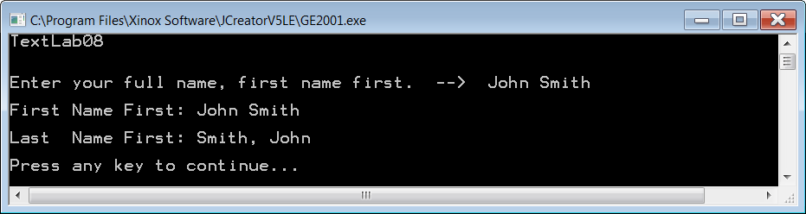

**100 Point Version**

For the 100 point version, you can assume that the user will enter at least 2 names. There will be a First Name and there will be a Last Name, but there can also be any number of Middle Names in-between. You cannot assume that the individual has exactly one middle name. Some people have 2 or more. Some people have none. You may assume that no extra spaces are entered by the user.

